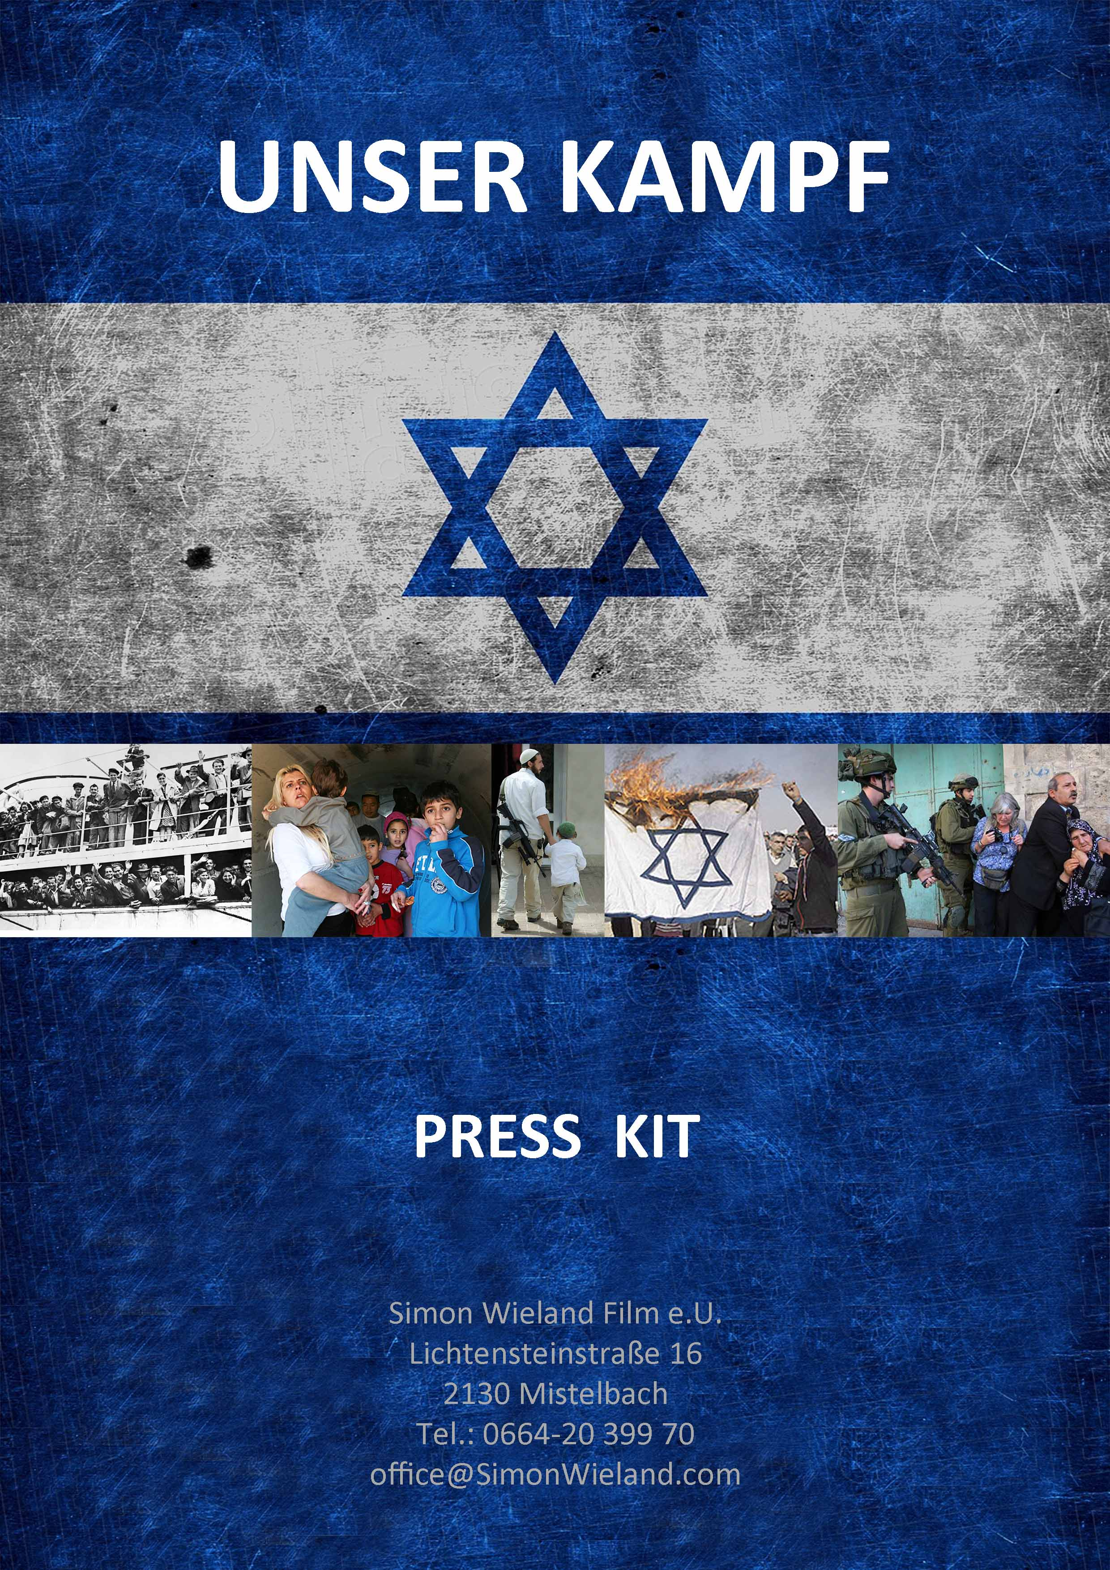

PRESS KIT

“Unser Kampf / Our Struggle”

Feature Film Documentary

90 min

Short synopsis:

The documentary film portrays a family whose grandparents fled to Israel after being expelled from Vienna and Cracow. For 75 years it has struggled to survive in the world’s most hated country – as victims and as aggressors.

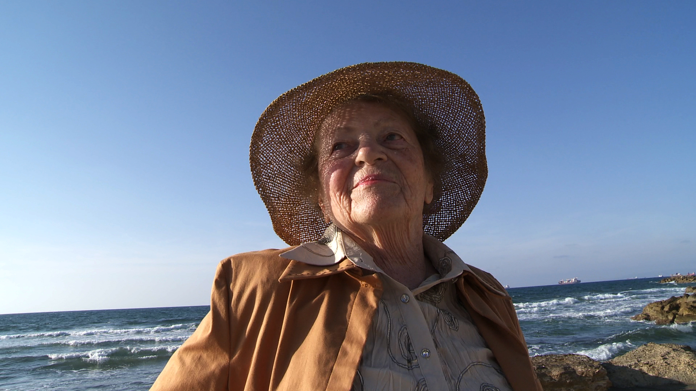

The Film:

The film documentary “Our struggle” explores the microcosm of an extended family from Vienna and Cracow, documenting the life and survival of three generations living in Israel, the most hated country in the world. The film shows the fate of family members in the face of nine wars, a permanent state of emergency, and ever new threats. As victims and as aggressors.

Hardly anyone knows anything about the history and living environments of the generation of people – and their descendants – who only became Israelis because they were driven out of their native countries.

The viewer “lives with” the family members and in this way gets a glimpse of a country and its people from a perspective that would otherwise remain buried and incomprehensible.

Through the eyes of the protagonist family we are offered a familiar but surprising, exciting and disparate picture of a country that is so foreign to us and yet so close.

The family saga, as a mirror of Israeli society, is mainly told from the perspective of the young Israelis, the so-called third generation.

We follow these women and men, who have in turn started families of their own, as they live their lives in the extraordinary environments of Tel Aviv, and Haifa. And through them we meet the parents and grandparents: the second and first generations.

Thus the film “Our Struggle” offers new insight into Israel’s society: Suddenly, within the microcosm of three generations of a family, Israeli history, its wars, conflicts, fears and hopes are given a face, brought to life, made concrete and tangible.

The viewer also becomes aware of how strongly the Holocaust continues to influence our “host” family in particular and Israeli society in general, both consciously and subconsciously.

In this way, the film seeks to peel away the outer layers of life in Israel until it finally reveals the hidden roots and conflicts of society.

Why this film?

Compared to the profound and widespread attempts in Germany and Austria to come to terms with the Holocaust in past decades, knowledge about the State of Israel – which was founded as a result of the Holocaust – and its people has remained superficial and marked by ignorance and prejudice.

Since it was founded in 1948 the State of Israel has been caught in a permanent struggle for survival. From the first night, in which our family was shot at by its Arab neighbor, to the present – since our family like all other Israelis is openly faced with extermination and new threats of genocide – the entire nation and its people have existed in a normal, everyday state of emergency.

“Even if we win every battle,” a second-generation family member says, “we still lost the war a long time ago!”

This is because many people in Austria and Germany think Israel as a nation has gone from being a victim to an aggressor and that as an occupying power it treats the Palestinians no better than the Nazis treated the Jews.

Through its depiction of the microcosm of one family’s history, the film offers a unique glimpse into the past, present, and future of the State of Israel, a continuum that is closely intertwined with our own past and at the same time reflects the current areas of conflict between the societies, cultures, and religions of the West and the East.

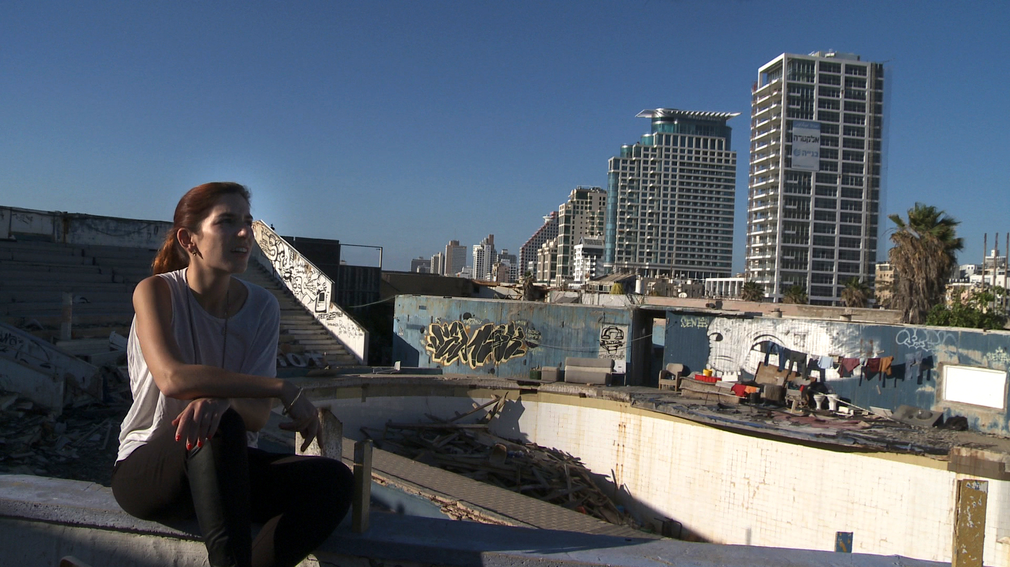

Director: Simon Wieland

Writers: Simon Wieland and Andreas Kuba

Interviewer: Andreas Kuba

Producer: Simon Wieland Film

www.simonwieland.com

Simon Wieland: born in 1963, filmmaker
Studied at the University of Television and Film in Munich, Germany, Feature Film Department.
As a cinematographer, he has shot several documentary films for ORF, 3Sat, and SABCO and made films in cooperation with or broadcast by BR, NDR, SFB, WDR, ORF, ARTE.
His films have received the distinction of “highly recommended” (“besonders wertvoll”) and have earned him a nomination for the German Film Award. He has also won special awards and praise at the San Francisco and Tel Aviv film festivals.
Lives and works as a writer, cinematographer, and director in Lower Austria, Vienna, and Munich. For many years his work has revolved around contemporary historical themes.
Current projects:

“Nemci Ven – Germans go Home” (director, cinematographer, producer). The documentary is about the deportation of an unimaginable three million German-speaking citizens from Czechoslovakia and the so-called Brno Death March, and accompanies expellees and expellers on their dramatic journeys into the unresolved, still smoldering past. 2013
“Coming Home” (director, cinematographer, co-producer) A documentary about the last generation of survivors of the Holocaust. It accompanies them when they come back to Vienna and revisit the places of their childhood, 2009.
“Heil Hitler – The Russians are Coming” (director, cinematographer, and producer) State of Lower Austria, Film/Television Agreement, Zukunftsfonds, ORF, 83-minute made-for-cinema documentary, 2010 People from the eastern part of Austria (Weinviertel) give personal accounts of the events that took place from 1938 to 1945.
“Killing Nazis” (co-director, cinematographer, co-producer)
The story of Alfred Müller, who grew up in Vienna's 16th district, Ottakring, and was forced to flee to Israel to escape the Nazis. In 1945 he returned to avenge his murdered family (nearly completed).

Andreas Kuba, born in 1965, journalist and writer
Lives and works in Vienna and Lower Austria
Journalist: AZ, Basta, founding member of NEWS, reporter for NEWS 1992–2002.
Initiator & project manager of “A Letter To The Stars”: (largest contemporary history project in Austrian schools, see: www.lettertothestars.at)
Documentary books “A Letter To The Stars”, “Holocaust: The Survivors”, “The Last Witnesses”, novel “Totort,”
Film documentaries: “Killing Nazis” (Rächer des Holocaust), “Coming Home” (Die letzten Zeugen)

